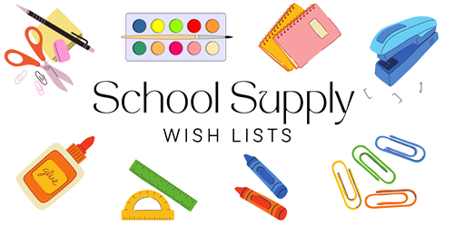

**5th GRADE**

**24/25**

1 BOX CRAYOLA COLORED PENCILS (24ct)

1 PACKAGE HIGHLIGHTERS 4ct ASSORTED COLORS

1 PACKAGE OF FRIXON ERASABLE PENS – ASSORTED COLORS

1 PAIR FISKARS 5” SCISSORS

1 PAIR HEADPHONES OR EARBUDS (A MUST)

2 LANYARDS WITH ID HOLDER

1 RECORDER FOR MUSIC CLASS

1 SPIRAL NOTEBOOK FOR SPECIALS (ANY COLOR)

1 PLASTIC FOLDER – ANY COLOR

1 REAM OF COPY PAPER

1 ROLL OF PAPER TOWELS

1 PACKAGE OF ELMER GLUE STICKS (4ct)

1 PACKAGE EXPO MARKERS (ANY COLOR) 4ct

3 PACKS #2 TICONDEROGA PENCILS (SHARPENED)

1 WIDE RULED COMPOSITION NOTEBOOKS – ANY COLOR

2 PACKS REINFORCED WIDE RULED PAPER

1 PENCIL POUCH

**GIRLS ONLY:**

1 BOX KLEENEX TISSUES (110ct)

**BOYS ONLY:**

1 BOTTLE OF HAND SANITIZER